The 2nd MATRIZ Great China Conference was successfully held
May 6-7, 2017, MATRIZ Great China conference was successfully in Shenzhen, China. The conference was hosted by Shenzhen Intellectual Property Society, a member of MATRIZ. The other MATRIZ members, Taiwan Innovation Development Association and Institute of Systematic Innovation co-hosted the conference. The other MATRIZ members in China also participated. Totally, there were more than 170 people in China (including Taiwan and Hongkong area) joined the conference. The working language is Chinese.
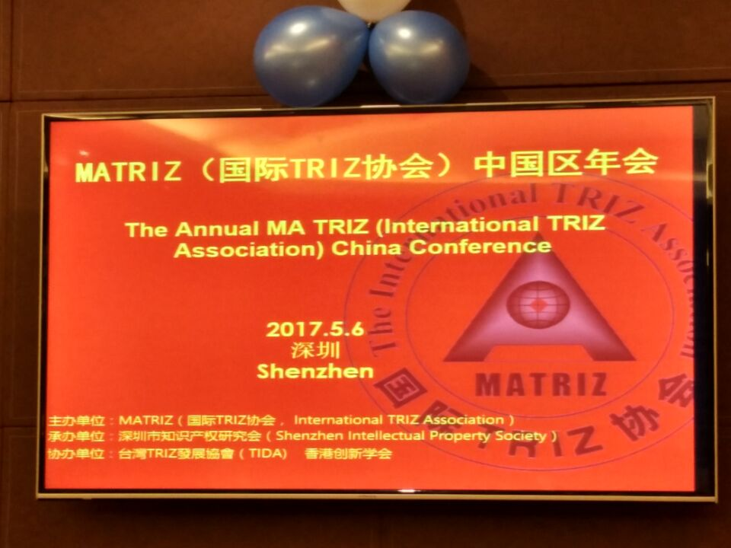
The event has 2 sessions. The 1st day was conference and the 2nd day is case sharing.
On the 1st day, Dr. Yongwei Sun, VP of MATRIZ delivered an opening speech on behalf Sergei Ikovenko, the President of MATRIZ. He also gave the awards to Mr. Dang Wei, TRIZ promotor in Vivo company and Mr. Yin Hanfan, the chairman of Shenzhen Intellectual Property Society.
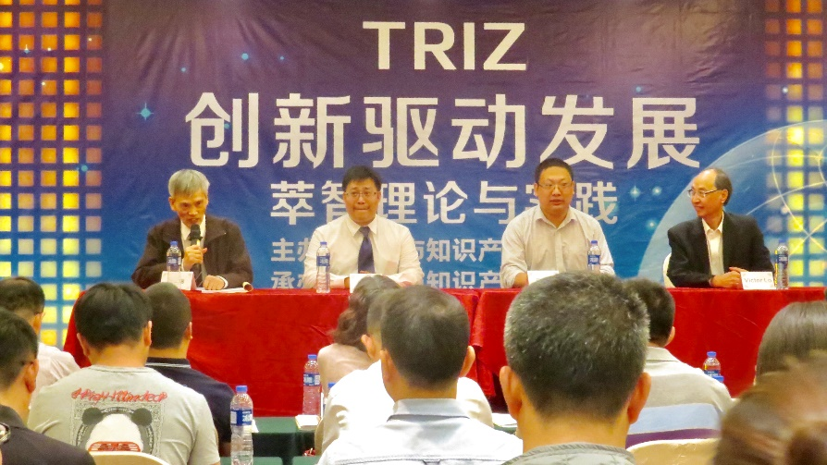

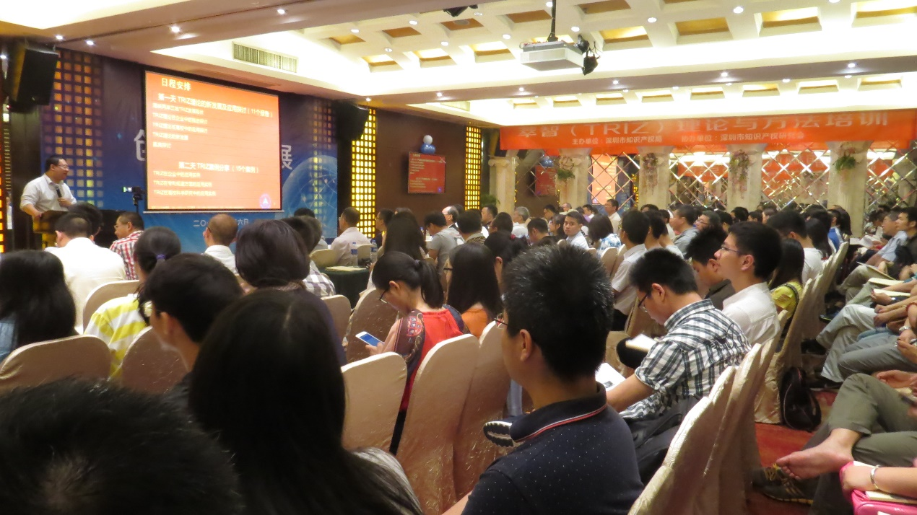
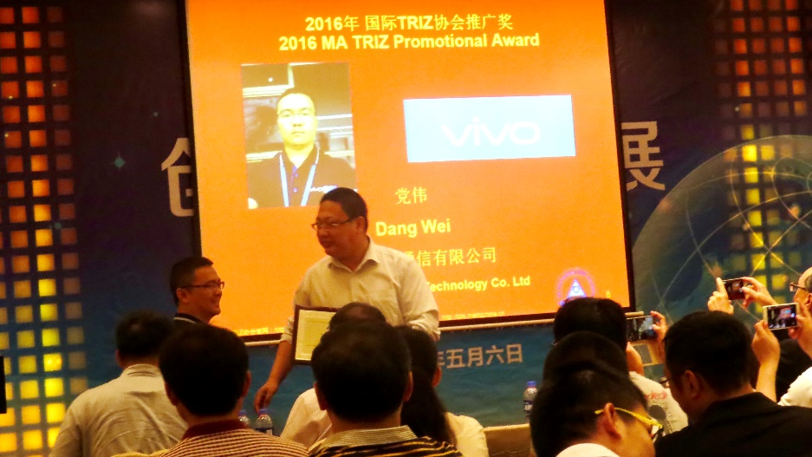
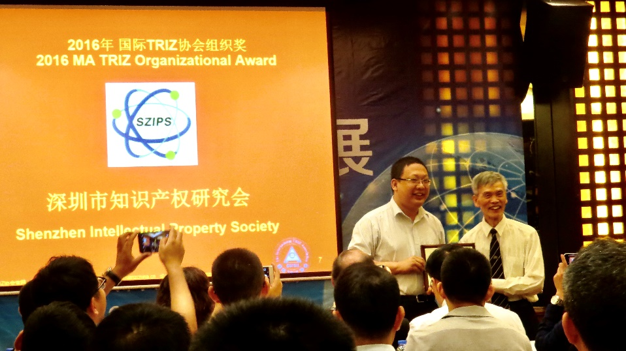

After that, there were 11 presentations. The topics are about TRIZ progress around the world, TRIZ in China mainland, Taiwan and Hongkong, TRIZ experience sharing in Vivo, TRIZ in Universities (education and research), TRIZ Review magazine, TRIZ methodology research…
The last of the day was panel discussion. The presenters of the answered the questions from the audiences and gave them professional suggestions.
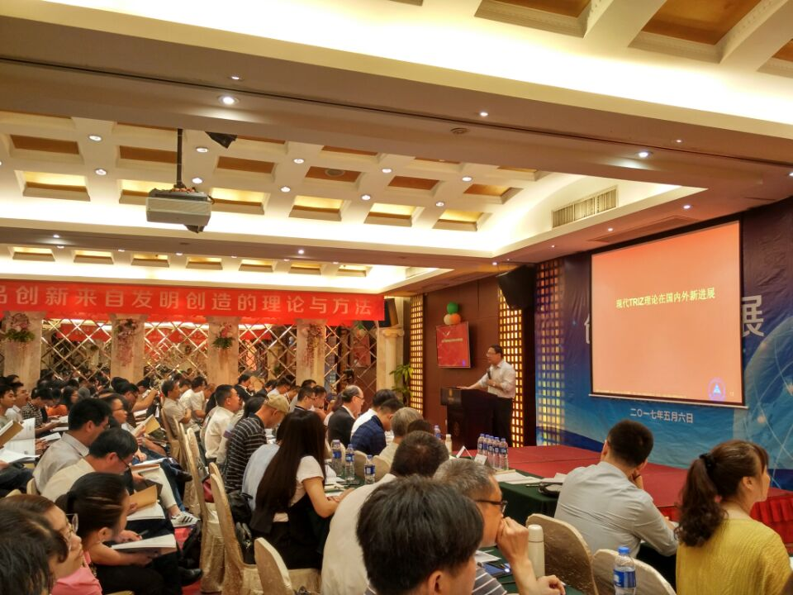
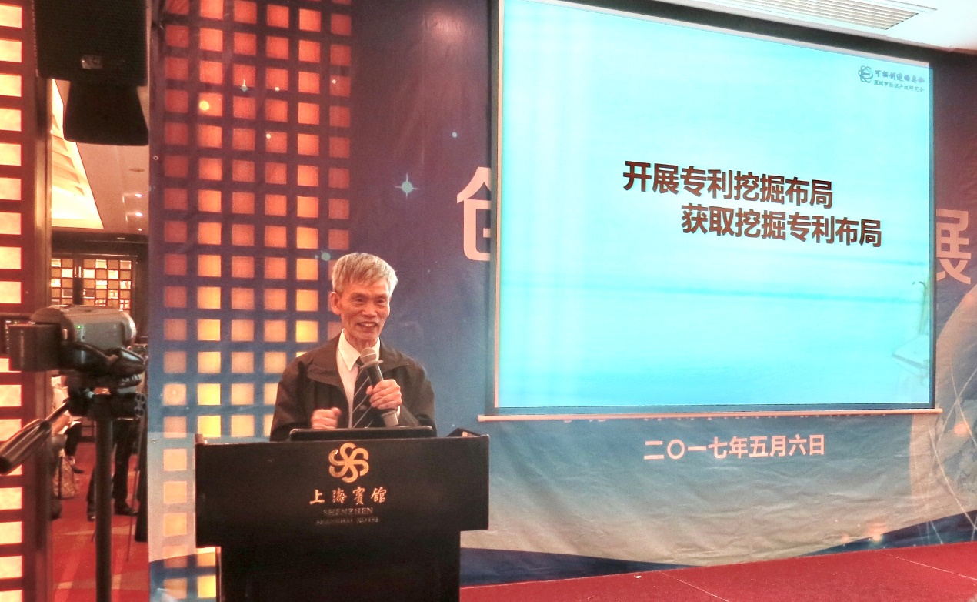

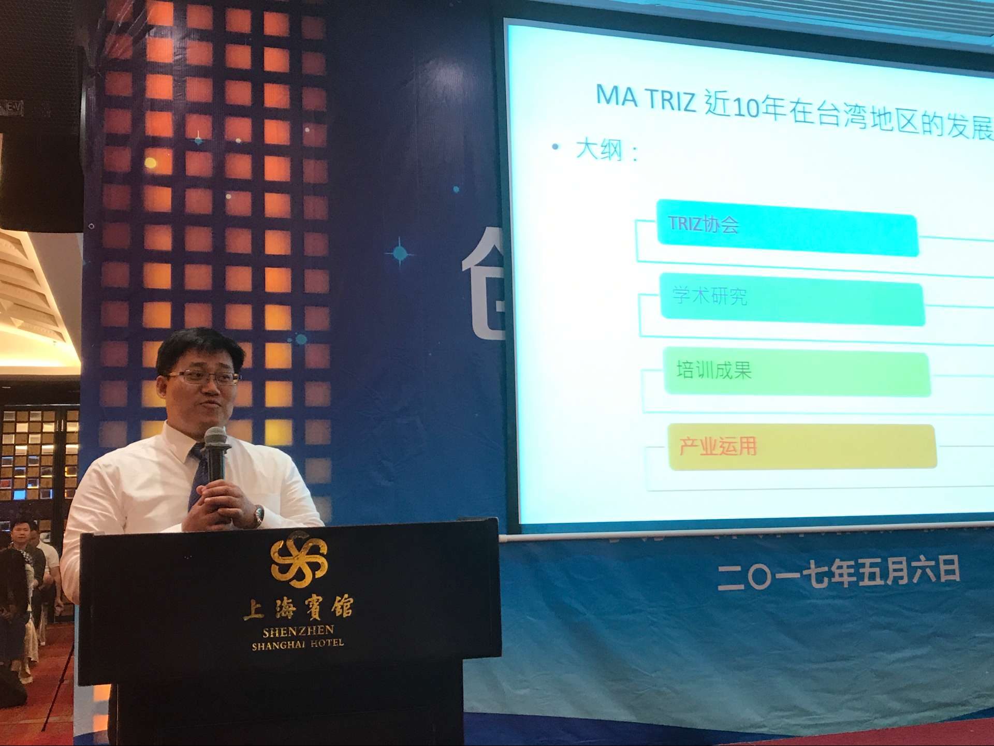
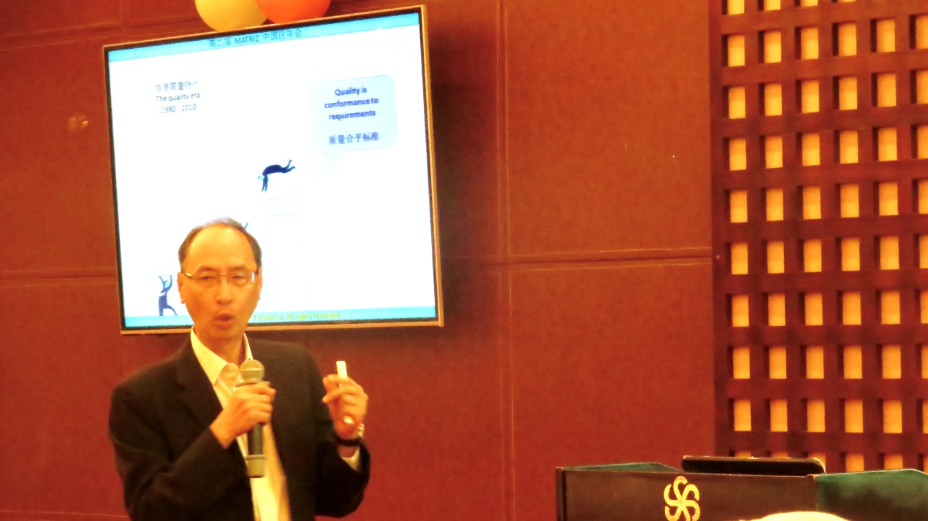

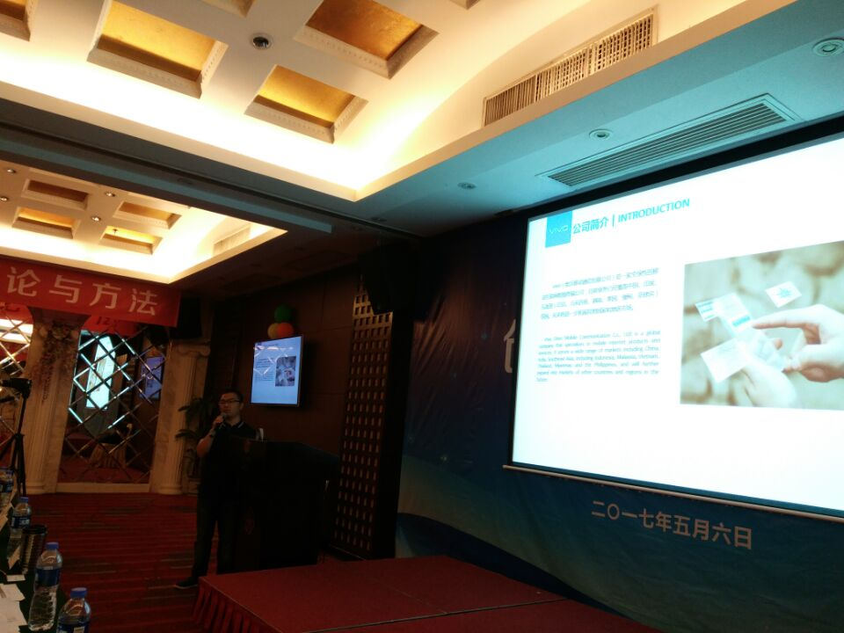
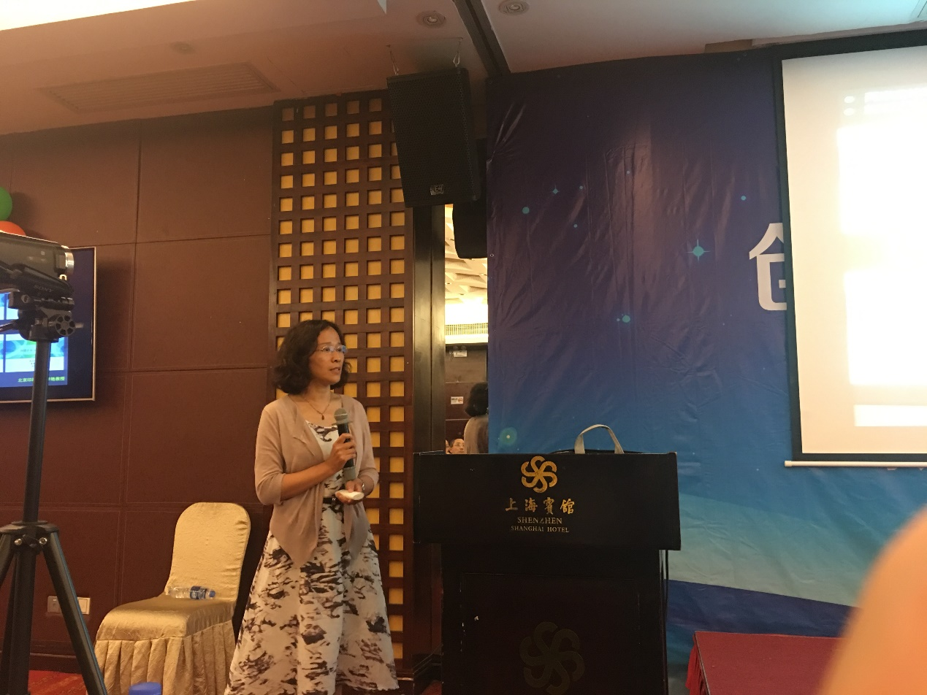
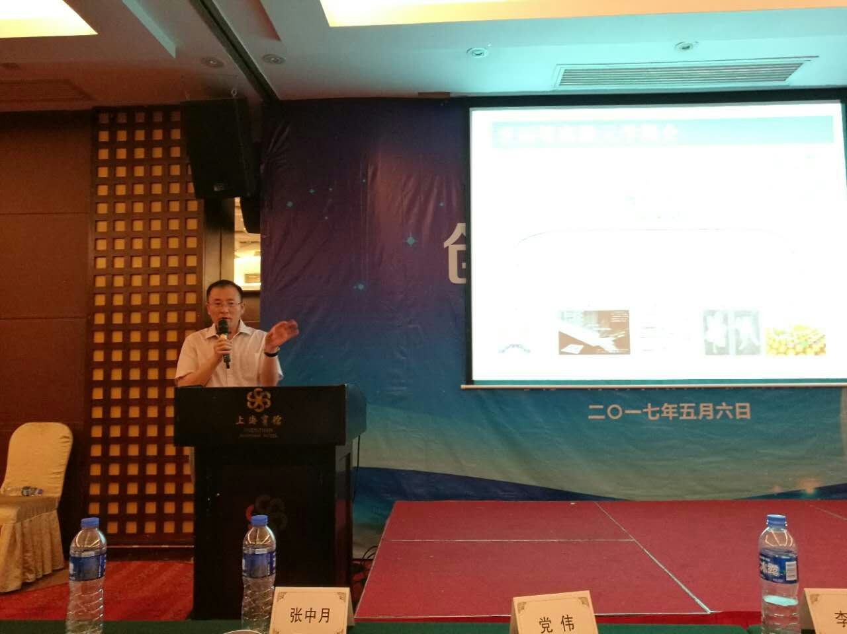
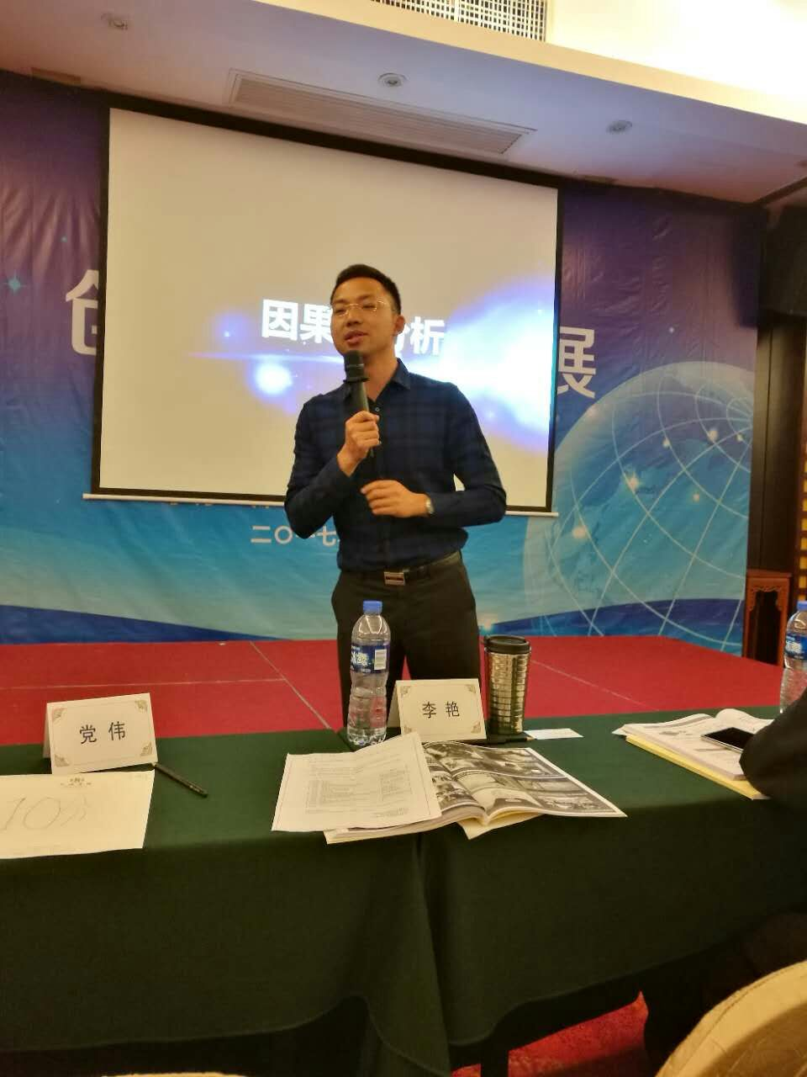
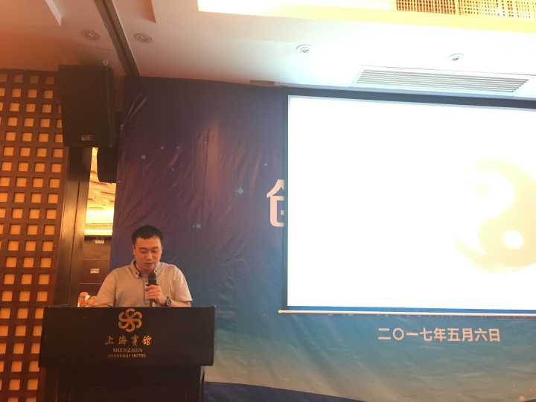

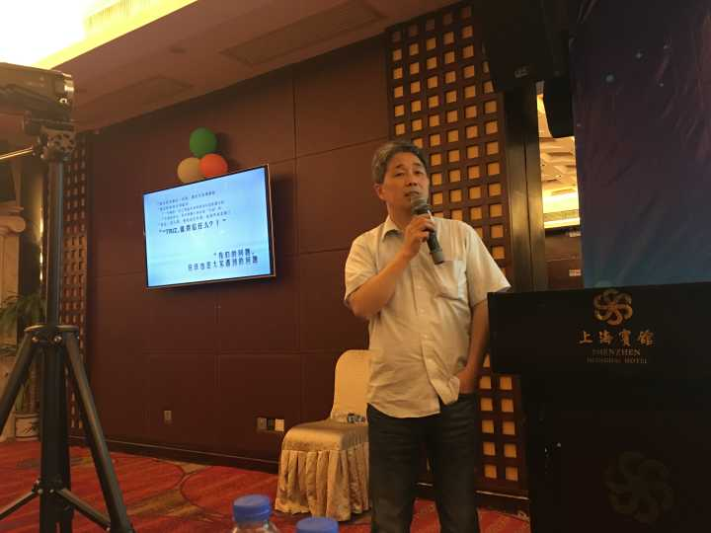
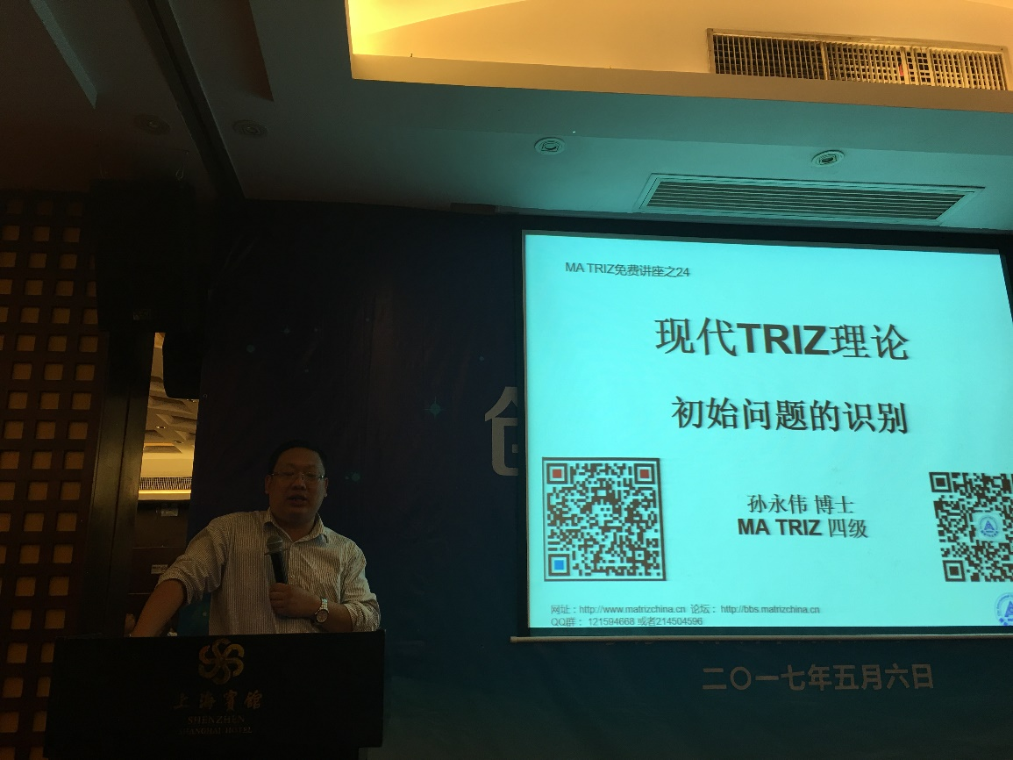

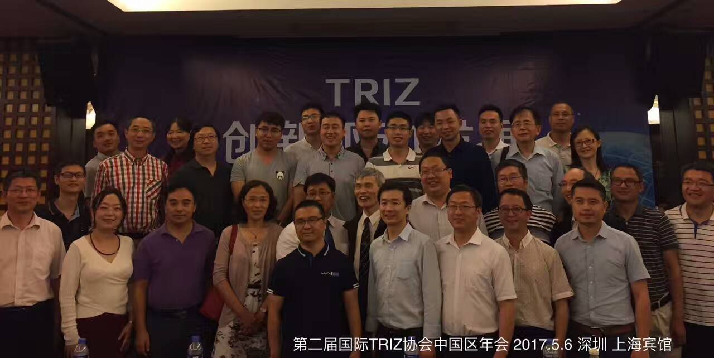

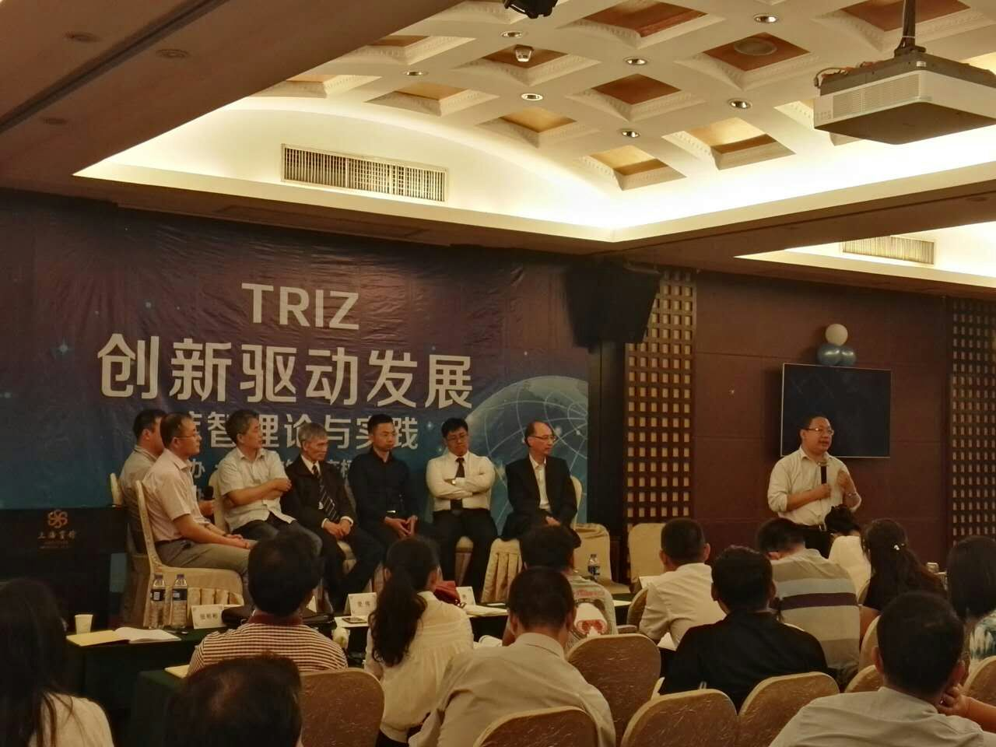
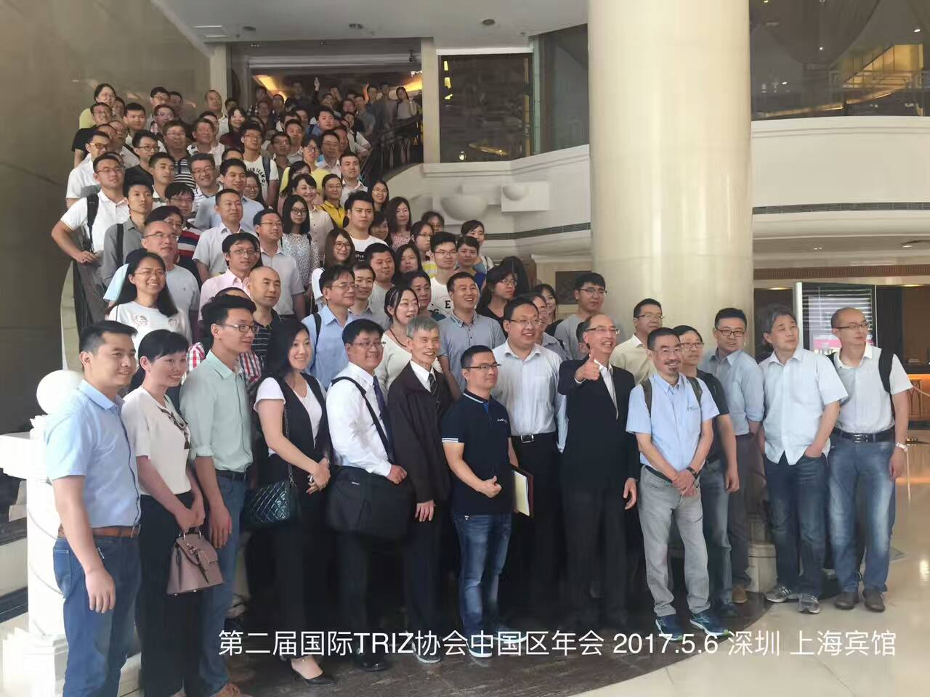
The 2nd day was case sharing session. There were 14 presenters shared 15 real examples. The examples are from chemical engineering, steel making, equipment development, electronics, printing equipment…
China has about 10 years’ experience in promoting TRIZ. However, there were not many TRIZ real cases shared and which caused the concern of TRIZ users. Could TRIZ be used for solving real problems?
The successful real cases removed the concerns in their mind and gave them more confidence of applying TRIZ in their own projects.
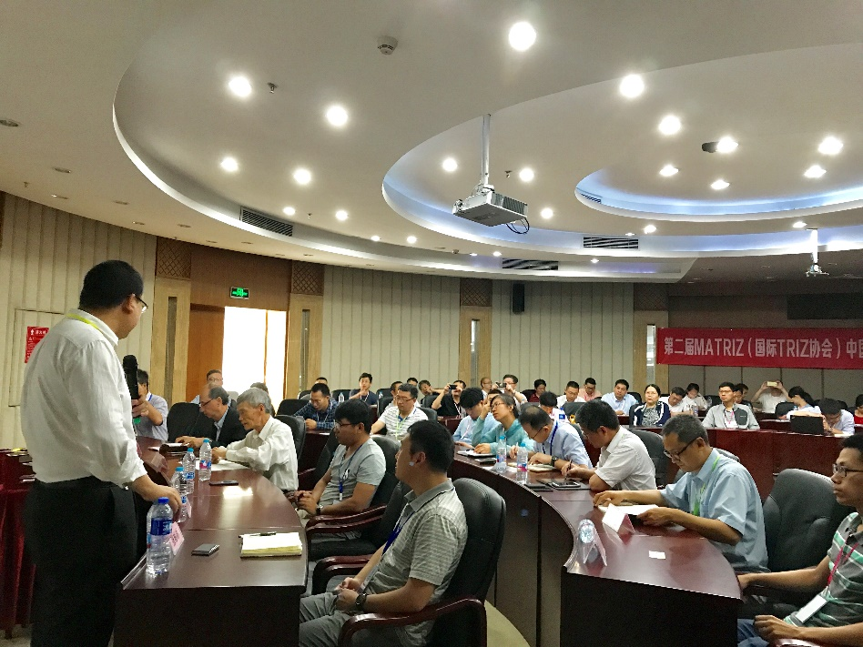

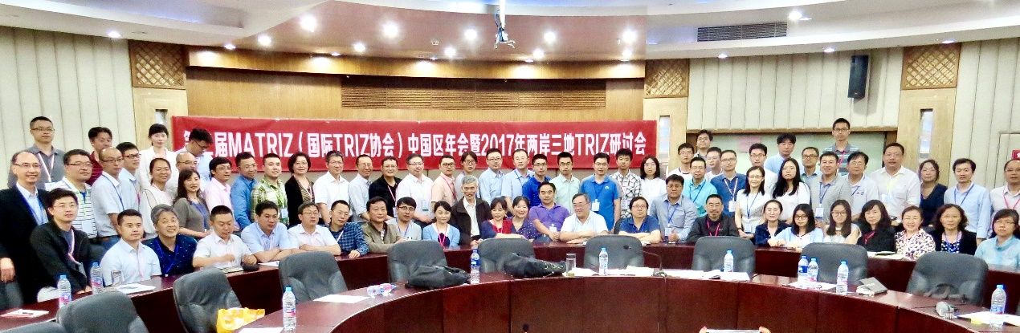

The conference was successfully closed with fruitful results and the next session is planned to be held in Hongkong.

